

**2025**

**Presidents’ Day**

**Tournament Information**

**Guide**

**SCHEDULE AND GENERAL INFORMATION**

1. **Play Schedule:**
2. The play schedule will be posted on [www.advancedeventsystems.com](http://www.advancedeventsystems.com). Scores will be updated after every match on Advanced Event Systems. Please make sure you look at your reffing and playing assignments as each day progresses.
3. Wave times will be Saturday 8:00 am – 2:00 pm and 3:00pm – 9:00 pm.
4. Pools will typically consist of three or four teams:
5. If your pool consists of 3 teams, it will be handled in one of two ways:  
   a) you will play two matches in your three-team pool and once the three-team pool completes its matches, the teams will be re-seeded and begin play in a cross-over match. In this scenario, only your first two matches will be listed on AES, and your third match will be determined once the three team pools are complete and teams are re-seeded.  
   b) you will play two matches with three sets to 25 each, with both matches being listed on AES
6. If your pool consists of 4 teams, your matches for the day will all be listed on AES.
7. Each team will play a minimum of three matches on Saturday. Each team is guaranteed 5 matches during the tournament. Once each wave starts, we will play ahead of schedule as play allows.

Check your schedule for your play site on Sunday as some teams will move to the United Wholesale Mortgage Sports Complex for their Sunday matches.

1. **Ticket Sales – Admission:**
2. **Single Day Pass:** $15
3. **2 Day Pass:** $25  
     
   Purchases can be made via credit card **only at the following site:**
4. [***Purchase Presidents’ Day Challenge Tickets here***](https://midwestevents.playerfirsttech.com/site/register/product?FromLodging=false&ProgramId=12007&ProductIds=%5b10195%2c10196%5d&affiliationId=295)

* Tickets will be sold using **GATE**.
  + **GATE** requires a FREE USER account. This must be set up prior to checking out for the first time.
  + GATE is a product of Player First. If your family already has a Player First account, you will use the same username and password to purchase for each event.
  + Please purchase your ticket at home before you get there. WIFI can be hit or miss, and your phone may be scrolling a long time before connecting which is very frustrating when you are trying to get in to watch your athlete.

1. The admission fee is good at all facilities for that day or the weekend with a 2-day pass if you move between facilities. Doors will open at each facility at 7:00 a.m. for players and spectators. Tickets will be sold at the door all day, Saturday and Sunday, at the entrance of each facility.
2. *IF YOU PURCHASE YOUR TICKET AHEAD OF TIME YOU WILL BE ABLE TO GO TO THE FAST LANE ENTRANCE TO EXPEDITE YOUR ENTRY.*

You will present your ticket on your phone to be scanned. Once your ticket is validated, you will receive a wristband for use throughout the weekend.

1. All spectators must wear a wristband to gain access to the area where the courts are located. We will have security monitoring the door checking for wristbands. Wristbands must be worn and not attached to a bag. Putting your wristband on a purse, bag, or anywhere other than your wrist will result in being denied entry to the playing area. There are no replacements for lost or forgotten wristbands.  If you lose your wristband, leave it at home, leave it in your hotel room, etc., you will need to purchase another one.  
   All sales are final.  No refunds will be given.

**Livestreaming:** BeTheBeast will be live-streaming all matches at all sites throughout the weekend. <https://mvc.bethebeast.com/eventliveplus>

1. **Team Check-in:**
2. TEAMS MUST CHECK IN ONLINE IN AES BETWEEN MONDAY FEB. 10, 2025, AND WEDNESDAY FEB. 12, 2025.
3. Rosters will be verified online when you check in online. There will be a check-in on Friday night for teams looking to pick up their bag tags from 5pm-7pm at the main entrance to Hall B in the Huntington Place Atrium.
4. Bag Tag pickup will also be available beginning on Saturday morning at 6:30am at the table outside the entrance to Hall B.
5. **Tournament Play:**
6. Matches will begin no later than 10 minutes from the conclusion of the preceding match.  Matches will begin ahead of schedule as play allows.  Wave start times will not be moved up. Subsequent rounds and bracket play matches will be moved up whenever time allows. At the start time, if teams are not ready to play, the opposing team will be awarded one point per minute. After ten minutes, the first game will then be forfeited. The second game and match will also be forfeited after an additional 10 minutes.
7. There are no caps for any sets. Third set will be up to 15, no cap.
8. Coaches are allowed to designate 2 liberos. The libero is allowed to serve for one position.
9. U12’s will serve from normal service line.
10. **Work Team Assignments:**
11. First official will be provided for all matches.  Each team is responsible to provide:  1 down official, 2 lines people, 1 official scorekeeper, 1 libero tracker and 1 person for flip score.  You are responsible for your own whistles.
12. No phones or food are allowed for the working teams at worktables.  All coaches/teams need to double check their reffing assignments throughout the weekend, especially Sunday. Please check in with your Site Director to insure your reffing duties are fulfilled before leaving on Sunday.
13. If you are late for your officiating assignment, the same penalties apply as to match and forfeit times.  All penalties will be carried over to the following day if necessary.  Please check closely to be sure you know the schedule.  If you are uncertain, please ask the tournament director at your site. On time means the start of warm-ups, not match start time.
14. It is required that a coach or other adult team representative remains at the scorer's table or bench area during team officiating assignments.
15. **During bracket play on Sunday, all losing teams must stay and provide the work team for the following match unless specified differently.** The game scheduled on your court may or may not be part of your division. If your match is switched to another court, you are still required to provide the work team.

**WARM-UP PROCEDURES**

1. For all matches during the event, warm-up time will be 2-4-4. 2 minutes for shared ball handling, 4 minutes for the serving team to have the entire court, 4 minutes for the receiving team to have the entire court.
2. Matches will be played ahead of schedule if possible. We are asking teams to help shag for the opponent during warm-ups to keep balls off other courts.
3. Warm-up balls are not provided at Huntington Place or at the United Wholesale Mortgage Sport Complex.
4. **SCHEDULE INFORMATION & RESULTS**
5. Complete posting of results and next round of play will be available on the Advanced Events Systems website (<http://www.advancedeventsystems.com>.) This is the official schedule. There will not be any posting of pool results around the tournament desk. Check the internet for all the results. Before leaving your site, be sure to check your schedule carefully for the next day. Site Directors and officials will not be held accountable for miscommunication or schedule interpretations. The official tournament posting on the internet is the only source that will be considered should a dispute arise.
6. **PLEASE ENSURE THAT YOU CAN ACCESS THE AES WEBSITE**
7. **ON YOUR PHONE OR MOBILE DEVICE**

**TIE BREAKING PROCEDURES**

1. During pool play, only ties in pools that affect who will advance to the Gold bracket in the Open & Premier Divisions will be considered for a tie-breaker match. All other divisions will be determined by the tiebreaking formulas in AES, which are outlined below.
2. Two-way ties - Head-to-head pool results will always determine the winner.

THREE-OR-MORE TEAMS TIE IN MATCHES

Three-way ties - If a three-way tie occurs in a pool that does affect advancement into the Gold Bracket in the Open or Premier Divisions, the results will be determined as follows:

1. Head-to-head results are used to determine pool finishes for teams that are tied in Match Record.

* + 1. a) A team that beats all the other teams with which it is tied in Match Record will finish ahead of the other teams in the pool.
    2. b) A team that has lost to all of the other teams with which it is tied in Match Record is placed behind the other teams in pool finish.
    3. c) If there are only two teams tied in matches after steps 1(a) and 1(b) have been applied, the head-to-head winner of those 2 teams earns the higher pool finish.
    4. d) If after applying steps 1(a), 1(b) & 1(c), teams remain tied, then the ranking of those remaining teams follows the procedure in step 2.

2. Set percentage is the 2nd level of breaking ties and is used to rank a pool in which teams remain tied after applying the rules in step 1.

* + 1. a) Teams with a higher set percentage finish ahead of teams with a lower set percentage.
    2. b) If only two teams are tied in both match percentage and set percentage, the team that won head-to-head receives the higher finish in the pool.

c) If three teams (or more) are tied in match percentage and set percentage after applying steps 2(a) & 2(b), the tie breaking procedure followed is based on pool finish among the teams tied in Match percentage and Set percentage is determined by Point percentage. If two teams are still tied in point percentage, the head-to-head winner finishes higher.

Three-way ties - If a three-way tie occurs in a pool that does not affect advancement into the Gold Bracket in the Open or Premier Divisions, the results will be determined as follows:

* Set winning percentage (if still tied)
* Point percentage within pool play
* Coin Flip

**PROTEST PROCEDURES:**

1. If a protest needs to be filed it must be done at the time of the incident, no later. The first referee is obligated to acknowledge and record all protests. For U15 -U18 teams, only the floor captain may file a protest. For U12-U14 teams, the coach or the floor captain may protest. The protest must be written on the score sheet by the official scorekeeper or the first-official and must be signed by the person presenting the protest as well as the first official. All protests will be ruled upon prior to the next service. Judgment calls may not be protested. Protests will be considered only for situations outlined in the United States Volleyball Official Rules booklet. The Head Official will handle all protests and their rulings are final.

**GENERAL RULES:**

1. Only AAU registered members are allowed on the court.
2. AAU Registered coach must be on the bench. A team without an AAU registered coach is considered incomplete and may not play.
3. Any abuse of tournament officials or staff by players, coaches or parents will result in that person’s removal from the tournament.
4. Chairs that are provided for team benches may not be moved or taken to another area.
5. Outside team food will not be allowed at any sites. Players may pack a lunch/dinner in their bag and concessions are available. You will be at your location for 6-7 hours. Check the information for each site below. Outside chairs are not allowed at any locations.
6. Tournament gear and t-shirts will be sold at all locations by Simaxx.
7. Trainers will be available at Huntington Place. Ice will be available at all locations. Bring your own tape and supplies if you need to be taped.

**PLAY SITE INFORMATION -** Smoking is not permitted inside or on the grounds of any facility.

* + Huntington Place (formerly TCF Center or Cobo Hall):
    - 1 Washington Blvd, Detroit MI 48226
    - No outside chairs allowed, plenty of seating available, full concessions available – **No warm up balls provided**
    - Parking at Huntington Place
      * See information below or click the link below for general parking information for the Convention Center.[Parking at Huntington Place](https://www.huntingtonplacedetroit.com/attendees/parking)
  + UWMSC - United Wholesale Mortgage Sports Complex (formerly Ultimate Soccer)
    - 867 South Blvd. E, Pontiac, MI 48341
    - No outside chairs allowed, plenty of seating provided, full concessions available, plenty of free parking available in lots on all sides of the complex, entrances in front and back of building **– No warm up balls provided.**

[Restaurants in Detroit](https://visitdetroit.com/inside-the-d/detroit-restaurants-guide/)

[Things to Do in Detroit](https://visitdetroit.com/destinations/downtown-detroit/)

[Parking at Huntington Place](https://www.huntingtonplacedetroit.com/attendees/parking)

[Directions to Huntington Place](https://www.huntingtonplacedetroit.com/attendees/getting-here)

[**Huntington Place Roof Deck Parking**](https://www.huntingtonplacedetroit.com/attendees/parking)The Huntington Place Roof Deck is located at the corner of Congress and Third Streets on the roof of the venue.  It features 1,200 uncovered parking spaces and provides easy access to Huntington Place.    
  
[**Huntington Place Washington Blvd. Garage**](https://www.huntingtonplacedetroit.com/attendees/parking)The Washington Boulevard garage is conveniently located at the corner of Larned St. and Washington Blvd., underneath Huntington Place. This garage features 640 covered parking spaces on two levels.    
  
[**Huntington Place Congress Street Garage**](https://www.huntingtonplacedetroit.com/attendees/parking)The Huntington Place Congress Street Garage is located at the intersection of Congress and First streets, underneath Huntington Place.  The Huntington Place Congress Street Garage features 350 covered and 56 uncovered parking spaces.



Welcome to Downtown Detroit! We are pleased to offer free service on the Detroit People Mover’s elevated trains, which will be a safe, quick and effective means of transportation between your host hotel and other venues. People Mover trains arrive every 7 minutes to deliver patrons in climate- controlled comfort. On-board security provides not only a watchful presence, but they also are a helpful resource should you need assistance.

Handicap accessibility is available via elevators at all stations.

**EXITING TO REACH HUNTINGTON PLACE**

Three DPM Stations are located within walking distance of Huntington Place:

HUNTINGTON PLACE / FORT/CASS FINANCIAL DISTRICT

For more information regarding our stations, the downtown district map or our renowned Art in the Stations exhibit, please visit [www.thepeoplemover.com](https://www.thepeoplemover.com).

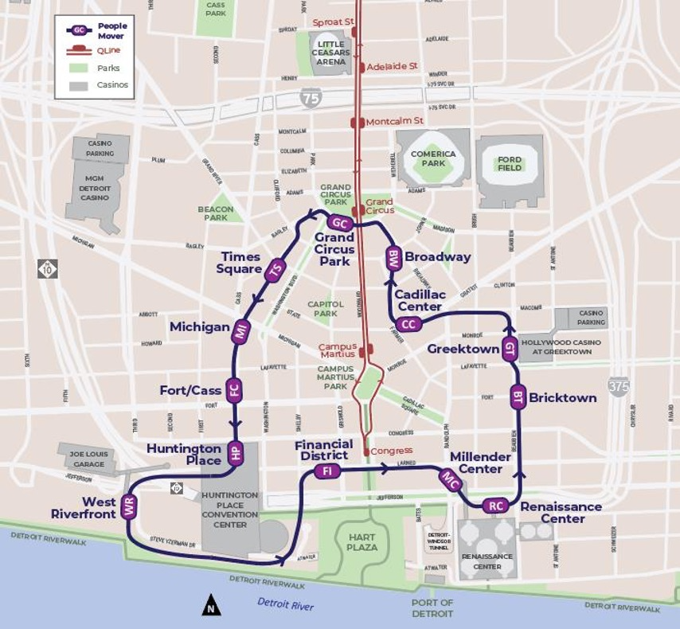

**PRESIDENT’S DAY VOLLEYBALL EXTENDED SERVICE HOURS**

**FEB. 15: 6:30AM – 12:00AM FEB. 16: 6:30AM – 10:00PM**

**ENJOY YOUR RIDE!**

**DIRECTIONS FROM DETROIT PEOPLE MOVER (DPM) STATIONS TO DOWNTOWN HOTELS**

**Aloft Hotel Guests**: Use the Grand Circus Park Station (GC)  
LOCATION: Connected to the hotel with entries on Park St. and Washington Blvd.

**ROOST Apartment Hotel at The Book Tower Guests**: Use Times Square Station (TS)  
LOCATION: Corner of Washington Blvd. and Grand River  
FROM THE STATION TO THE HOTEL: Exit Times Square and turn right. Turn right on Washington Blvd.

**Westin Book Cadillac Hotel and Hotel Indigo Guests**: Use the Michigan Avenue Station (MI)  
LOCATION: On Washington Blvd., on the corner of Michigan and Cass Avenues  
FROM THE STATION TO THE HOTEL: Upon exiting the station, turn right and walk one block up Michigan Ave.

**DoubleTree Suites by Hilton Detroit and Cambria Hotel Guests**: Use the Fort/Cass Station (FC)  
LOCATION: Cass Ave. before Fort Street  
FROM THE STATION TO THE HOTEL: Exit Fort / Cass Station and turn left. Walk to Lafayette Blvd. and turn left. The hotels are approx. 2-3 blocks.

**Fort Pontchartrain Wyndham and Detroit Foundation Hotel Guests**: Use the Financial District Station (FI) or Huntington Place Station (HP)

LOCATIONS: Huntington Place – Level 4 or Financial District Station on Larned Ave.  
FROM THE STATION TO THE HOTEL: Exit Huntington Place using elevators or escalators and walk to the corner of Washington Blvd. and Larned. The hotels are across the street.

**Courtyard by Marriott Detroit Hotel Guests**: Use the Millender Center Station (MC)

LOCATION: Level 5, via escalator or elevator  
FROM THE STATION TO THE HOTEL: Exit and take the elevator down to the lobby.

**Detroit Marriott Renaissance Center Hotel Guests**: Use the Renaissance Center Station (RC)  
FROM THE STATION TO THE HOTEL: Exit the Renaissance Center Station; Guests walk out into Tower 200. Proceed left toward the GM Renaissance Center circulation ring. Guests may travel either left or right inside the ring to reach the

**Marriott Renaissance Center located in Tower 400.Atheneum Hotel Guests**: Use the Greektown Station (GT) Entrance on Beaubien St. LOCATION: Level 2, via escalator, stairs (located to the right from the Beaubien Entrance) or elevator (located to the far left of the Beaubien Entrance).

FROM THE STATION TO THE HOTEL: Exit the Greektown Station from the platform either by pedestrian stairwell on the right or by elevator down to Beaubien, turning right to Monroe & left on Brush.

**Hollywood Greektown Casino Hotel Guests**: Use the Greektown Station (GT)  
LOCATION: Level 2, via escalator, stairs (located to the right from the Beaubien Entrance) or elevator (located to the left of the Beaubien Entrance) FROM THE STATION TO THE HOTEL: Exit the Greektown Station from the platform either by (1) pedestrian stairwell to the left down to Monroe Street, turning right and walking 1.5 blocks on Monroe to the hotel or (2) from Beaubien, turning right to Monroe & walking straight ahead.

**Hilton Garden Inn Guests**: Use the Cadillac Center Station (CC)  
LOCATION: Gratiot Ave. and Brush St.  
• FROM THE STATION TO THE HOTEL: Upon exiting the station, turn right and proceed three blocks to Gratiot.

**Element at the Metropolitan, Shinola and Siren Hotel Guests**: Use the Broadway Station (BW)  
LOCATION: Broadway and John. R. next to the Boll Family YMCA  
• FROM THE STATION TO THE HOTEL: Turn left immediately after exiting. Continue straight ahead for the Siren Hotel. Make another left onto John R. for the Element (right side) or Shinola on Woodward.

**AAU GRAND PRIX REQUIREMENTS:**

1. Teams winning a Super Regional or Grand Prix event will be reimbursed the entry fee provided they contact [volleyball@aausports.org](mailto:volleyball@aausports.org) by July 1st, 2025. **Refund requests will not be accepted after July 1st, 2025**. **It is the responsibility of the Tournament Host to relay this information to winning teams. Winning teams WILL NOT automatically be refunded, nor will they be contacted by the National Office.**
2. This is not a bid; your team must be registered & accepted (which includes paid) for either the AAU National Championships or The Volleyball festival before your division closes. This is a team award for the current season and may not be passed to another team in your club or saved for the future. If your division is closed, you have the option to be put on the wait list or enter another division in the same age group.
3. Girls’ teams can choose to use their free/discounted entry fee for the AAU National Championships or the Volleyball Festival. Boys’ teams can only use their free/discounted for the AAU National Championships.
4. Teams participating in multiple events can only earn one entry fee for the National Championships or one entry fee for the Volleyball Festival. Teams cannot earn multiple entry fees for the same event. All teams must still register for the AAU National Championships or Volleyball Festival by the appropriate entry deadline and/or before the event has sold out. **Spots will not be automatically held for winning teams**. All teams must follow the entry requirements and policies as outlined in the event information packet. It is the responsibility of the event Host to relay this information to participating teams.
5. Teams earning a free or discounted entry fee must contact the AAU National Office by July 1st, 2025.
6. Refunds will be issued after the National Tournament or The Volleyball Festival.
7. It is the winning team’s responsibility to contact [volleyball@aausports.org](mailto:volleyball@aausports.org) to receive their free or discounted entry fee. **Refund requests will not be accepted after July 1st, 2025**. Winning teams **WILL NOT** automatically be refunded, nor will they be contacted by the National Office. participated in the event of their choice
8. If the first-place team has previously won a Super Regional or Grand Prix or is not attending either the National Championships or the Volleyball Festival, the entry fee will drop down to the second-place team. The entry fee will not drop to any teams below second place.
9. The free/discounted entry fee applies only to the team that won the event. The club cannot apply it towards a different team within the same club.
10. The National Championships and Volleyball Festival are open to all teams meeting the entry requirements, regardless of placement or participation in a Super Regional or Grand Prix tournament.
11. **Super Regional Guidelines** 
    1. **Any team meeting the AAU membership requirements and rules can participate.**
    2. **The tournament is open to teams nationwide and not limited to teams within a District or Region. There will be a limited number of Super Regionals conducted, so teams from outside of your District should be** invited.
12. Rules of the AAU National Championships must be followed. This includes, but is not limited to:
    1. All participants must meet the age requirements.
    2. All players must live within the AAU District of their team or in a bordering District and comply with the guidelines set forth in the AAU Code Book. Adult members are not bound by residence requirements. Hawaii, Alaska and US Territories, including Puerto Rico, do not have bordering Districts.
    3. The Libero player may serve in one rotation in a set.
    4. Boys are not permitted on girls’ teams. Girls are not permitted on boys’ teams.
    5. For additional rules, please refer to the AAU Volleyball Handbook and National Championships Rules.

**For additional information, please contact AAU Volleyball at 407-934-7200 or** [**volleyball@aausports.org**](mailto:volleyball@aausports.org)